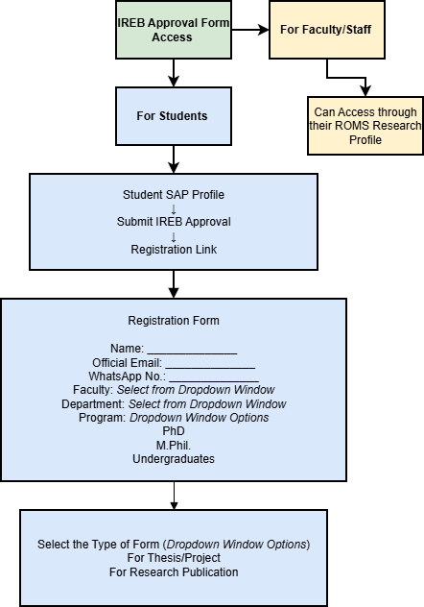
Faculties for Form Category “All Other Department”
- Faculty of Engineering & Technology
- Faculty of Information Technology
- Faculty of Management Sciences
- Faculty of Sciences
- Faculty of Arts and Architecture
- Faculty of Law
- Faculty of Social Sciences
- Faculty of Languages and Literature
Faculties for Form Category “Medical and Health Sciences”
- Faculty of Pharmacy
- Faculty of Allied Health Sciences
- Faculty of Medicine and Dentistry

